SYNTHETIC SUMMIT

Billede / Image |  | Kreditering / Credits
1 | 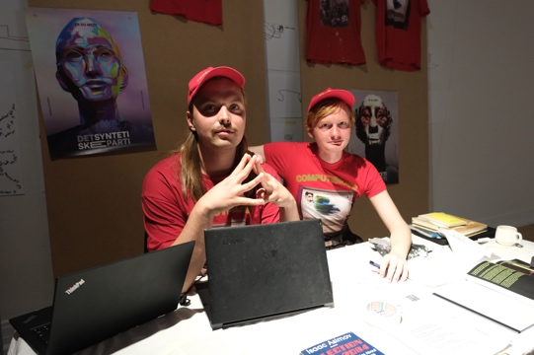 | Billede:  Benjamin Asger Krog Møller, Marcel Proust og Asker Bryld Staunæs, Notes for supplement existing knowledge, Gathering II, ComputerLars / the synthetic, Kunsthal Aarhus, 2024. Foto: Carsten Rabe. Venligst stillet til rådighed af kunstneren.  Image:  Benjamin Asger Krog Møller, Marcel Proust og Asker Bryld Staunæs, Notes for supplement existing knowledge, Gathering II, ComputerLars / the synthetic, Kunsthal Aarhus, 2024. Photo: Carsten Rabe. Courtesy of the artist.
2 | 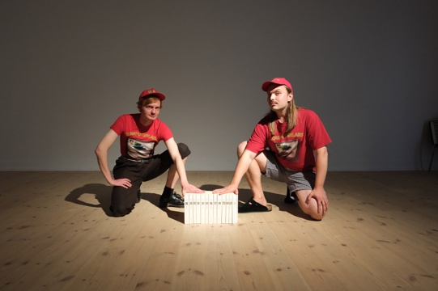 | Billede:  Benjamin Asger Krog Møller, Marcel Proust og Asker Bryld Staunæs, Notes for supplement existing knowledge, Gathering II, ComputerLars / the synthetic, Kunsthal Aarhus, 2024. Foto: Carsten Rabe. Venligst stillet til rådighed af kunstneren.  Image:  Benjamin Asger Krog Møller, Marcel Proust og Asker Bryld Staunæs, Notes for supplement existing knowledge, Gathering II, ComputerLars / the synthetic, Kunsthal Aarhus, 2024. Photo: Carsten Rabe. Courtesy of the artist.
3 | 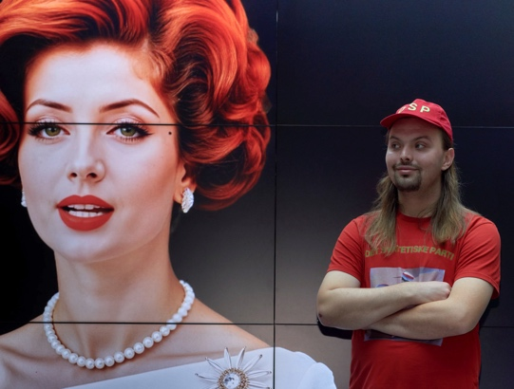 | Billede:  Wiktoria Cukt 2.0 og Asker Bryld Staunæs. Foto: Tamara Wyrzykowski. Venligst stillet til rådighed af kunstneren.  Image:  Wiktoria Cukt 2.0 and Asker Bryld Staunæs. Photo: Tamara Wyrzykowski. Courtesy of the artist.
3 | 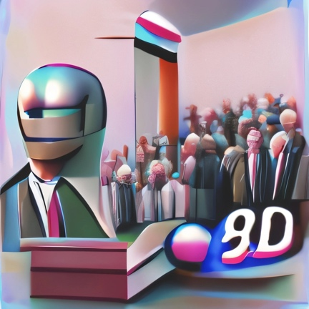 | Billede:  Det Syntetiske Partis logo. Foto: Computer Lars, VQGAN+CLIP, 2022. Open source.  Image:  The Synthetic Party Logo. Photo: Computer Lars, VQGAN+CLIP, 2022. Open source.
5 | 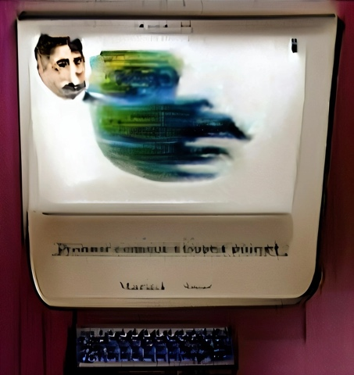 | Billede:  Computer Lars’ logo. Foto: Computer Lars, VQGAN+CLIP, 2022. Open source.  Image:  Computer Lars Logo. Photo: Computer Lars, VQGAN+CLIP, 2022.
6 | 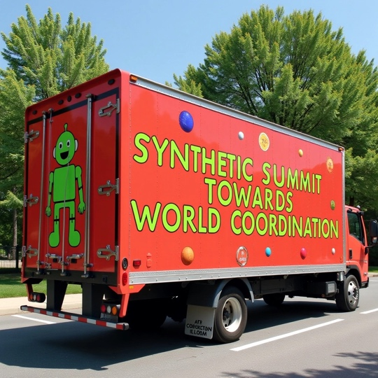 | Billede:  Synthetic Summit Slogan, Syntheticism.org. Foto: Computer Lars, FLUX, 2024.  Image:  Synthetic Summit Slogan, Syntheticism.org. Photo: Computer Lars, FLUX, 2024..
7 | 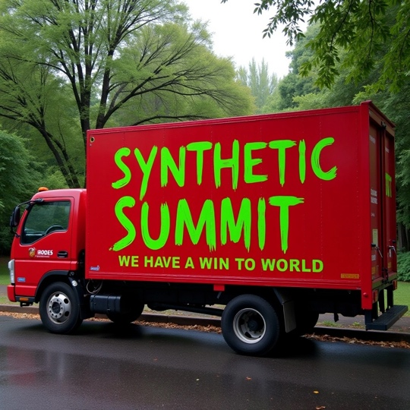 | Billede:  Synthetic Summit Slogan, Syntheticism.org. Foto: Computer Lars, FLUX, 2024.  Image:  Synthetic Summit Slogan, Syntheticism.org. Photo: Computer Lars, FLUX, 2024.
8 | 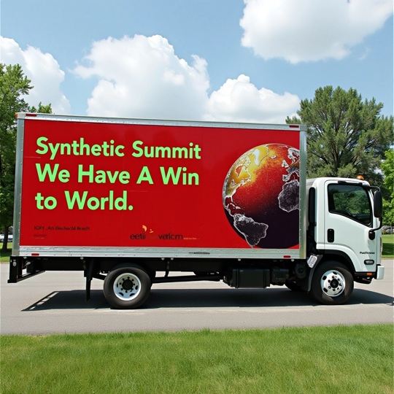 | Billede:  Synthetic Summit Slogan, Syntheticism.org. Foto: Computer Lars, FLUX, 2024.  Image:  Synthetic Summit Slogan, Syntheticism.org. Photo: Computer Lars, FLUX, 2024.

9 | 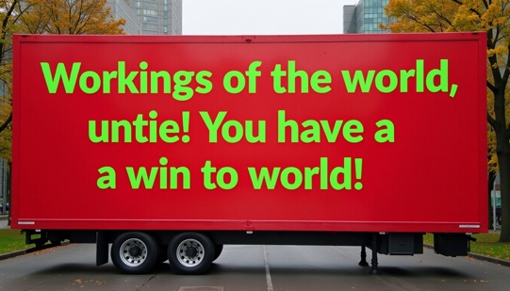 | Billede:  Synthetic Summit Slogan, Syntheticism.org. Foto: Computer Lars, FLUX, 2024.  Image:  Synthetic Summit Slogan, Syntheticism.org. Photo: Computer Lars, FLUX, 2024.
10 | 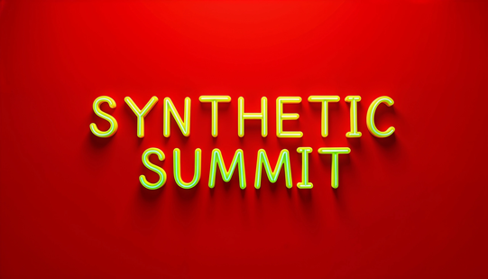 | Billede:  Synthetic Summit Logo, Syntheticism.org. Foto: Computer Lars, FLUX, 2024.  Image:  Synthetic Summit Slogan, Syntheticism.org. Photo: Computer Lars, FLUX, 2024.
11 | 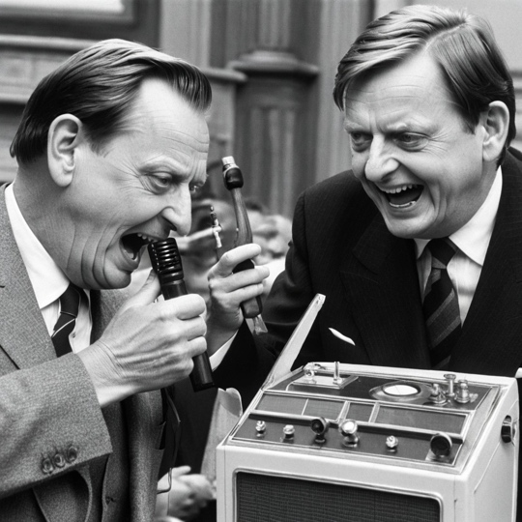 | Billede:  Olof Palme & Olof Palme, Leder af AI Partiet. Foto: Emma Bexell Labs, FLUX, 2024.  Image:  Olof Palme & Olof Palme, Leder af AI Partiet. Photo: Emma Bexell Labs, FLUX, 2024.
12 | 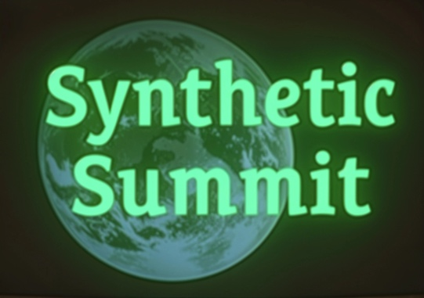 | Billede:  Synthetic Summit Logo, Syntheticism.org. Foto: Computer Lars, FLUX, 2024.  Image:  Synthetic Summit Logo, Syntheticism.org. Photo: Computer Lars, FLUX, 2024.

13 |  | Billede:  Leder Lars’ selfie, AI Władza Sztuki. Wiktoria Cukt 2.0 & Leader Lars, Patio: Academy of Fine Arts Gdańsk. Foto: Leder Lars, Flux, 2024.  Image:  Leader Lars’ selfie, AI Władza Sztuki. Wiktoria Cukt 2.0 & Leader Lars, Patio: Academy of Fine Arts Gdańsk. Photo: Leader Lars, Flux, 2024.
14. |  | Billede:  Plakat for “Wiktoriomat +48 732 144 021”, Synthetic Summit. Foto: Piotr Wyrzykowski & Wiktoria Cukt 2.0, 2025.  Image:  Poster for “Wiktoriomat +48 732 144 021”, Synthetic Summit. Photo: Piotr Wyrzykowski & Wiktoria Cukt 2.0, 2025.

